Test Case: runTestMultipleTimes
Step 1 - Enter username and password and click to button Enter : Credentials Entered
Image file-name: QC_Testing-runTestMultipleTimes-dic. 04 2025, 03 39 20 p. m.

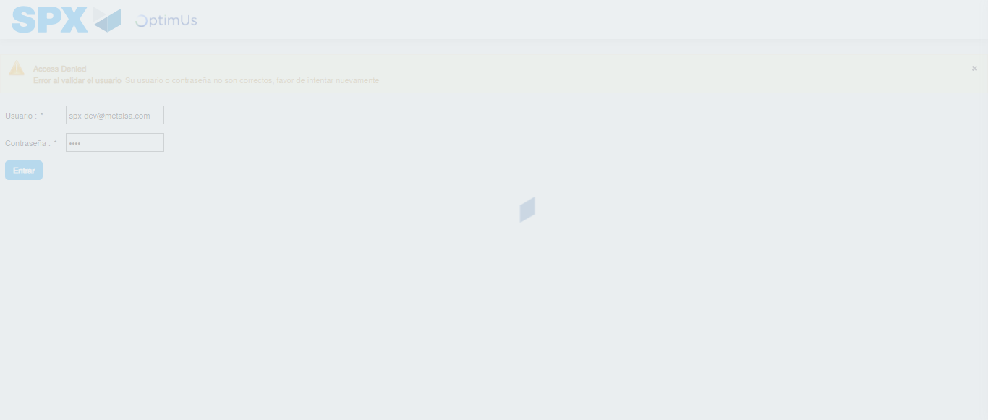Image file-name: QC_Testing-runTestMultipleTimes-dic. 04 2025, 03 39 21 p. m.

Step 2 - Select to UEN and Access to Administrador Roles Menu: UEN Correctly selected and Correct access
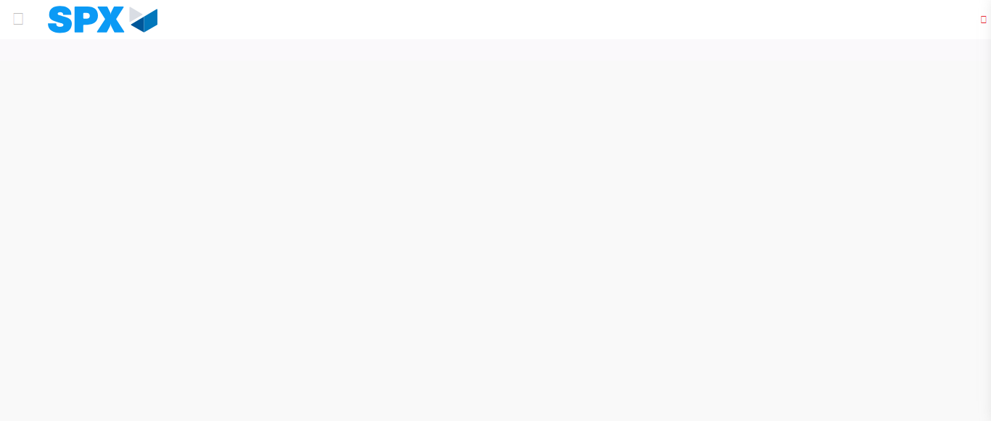Image file-name: QC_Testing-runTestMultipleTimes-dic. 04 2025, 03 39 28 p. m.

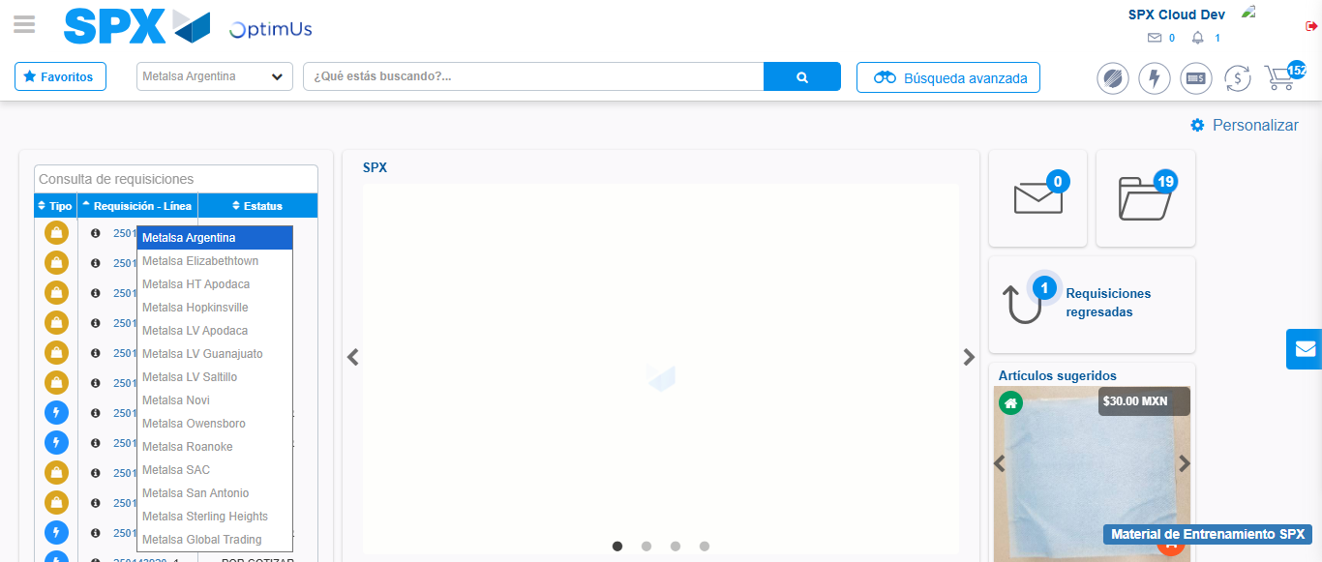Image file-name: QC_Testing-runTestMultipleTimes-dic. 04 2025, 03 39 30 p. m.

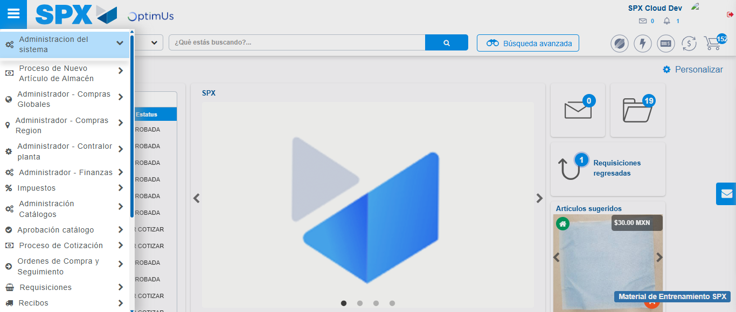Image file-name: QC_Testing-runTestMultipleTimes-dic. 04 2025, 03 39 31 p. m.

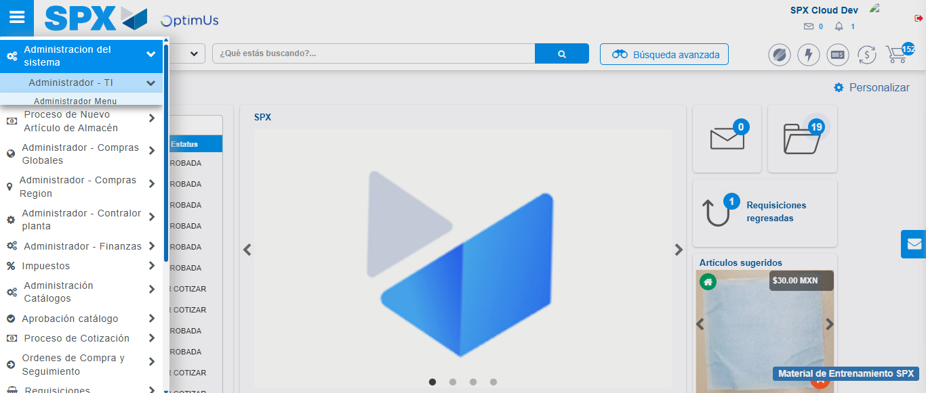Image file-name: QC_Testing-runTestMultipleTimes-dic. 04 2025, 03 39 32 p. m.

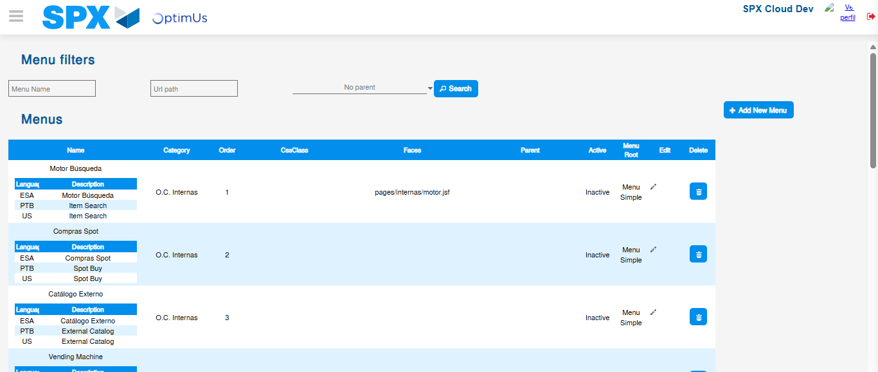Image file-name: QC_Testing-runTestMultipleTimes-dic. 04 2025, 03 39 33 p. m.

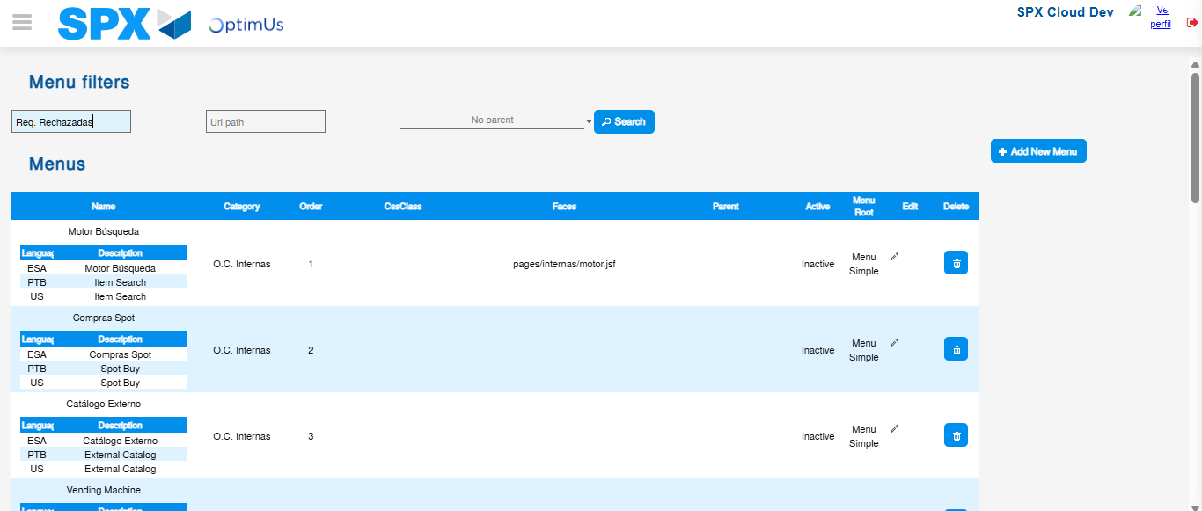Image file-name: QC_Testing-runTestMultipleTimes-dic. 04 2025, 03 39 34 p. m.

Step 3 - Perform a search with the Menu Name filter: Successful search
Image file-name: QC_Testing-runTestMultipleTimes-dic. 04 2025, 03 39 34 p. m.

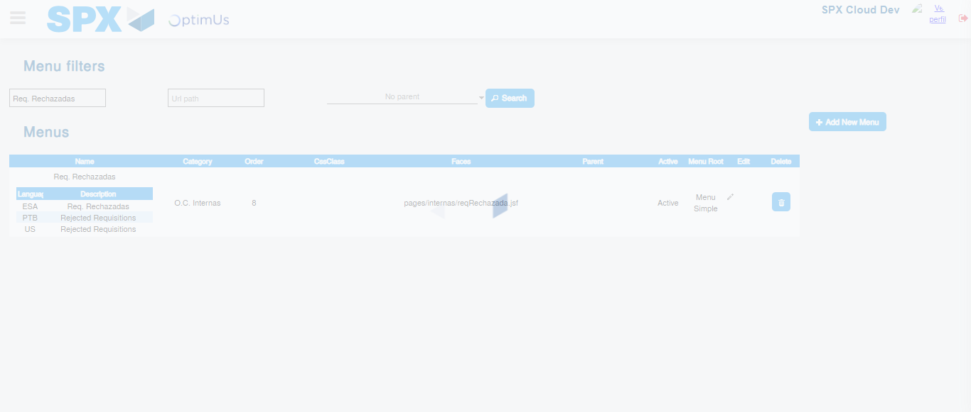Image file-name: QC_Testing-runTestMultipleTimes-dic. 04 2025, 03 39 35 p. m.

